December, 9, 2013

Cub Scout Pack 52
C/O Lance Moore

Greetings Lance,

It was great to speak with you last week and work out the final details of our exploratory partnership. As you know Highpoint Church does not rent out its facilities. However, we do offer our facilities for free to organizations that share our values and passion for reaching the poor and less fortunate of urban Aurora.

Therefore, I am submitting this proposal for partnership for your review. It incorporates both of your requests. If it meets your approval we can both sign it and proceed accordingly. Should this kind of partnership not be something you are interested in we would totally understand. I remain,

Excited to explore this partnership,

Gene Roncone
Lead Pastor, Highpoint Church

Partnering for the Poor
Proposed Partnership between Highpoint Church and Cub Scout Pack 52

The following is a proposed exploratory partnership between Highpoint Church and Cub Scout pack 52. Highpoint Church does not rent out its facilities. However, we offer our facilities for free to organizations that share our values and passion for reaching the poor and less fortunate of Aurora’s Urban Corridor. We would like to partner with Pack 52 to provide food and hygiene kits for Aurora’s homeless through Aurora Warms the Night.

Normally Highpoint does not allow use of the facilities later than 2PM on Saturdays. However, Pastor Gene has agreed to make an exception in an exploratory partnership consisting of the following two (2) events listed in chronological order.

- Pack 52 Pinewood Derby – (Saturday, January 18, 2014) Noon – 5PM

- Highpoint’s Contribution.
  - Donate facility use: Highpoint Church will donate the use of the 12,000 square foot atrium for five (5) hours.
  - Donate the use of tables and chairs: Highpoint church will donate the use of 120 black-folding chairs and the needed white plastic tables.
  - Donate utilities: Highpoint Church will donate the expense of heating and utilities for the atrium. Because the atrium has 35-foot ceiling and over 12,000 square feet of space it is the most expensive room in the church to operate.
  - Hygiene supply list: Highpoint Church will provide a detailed supply list with pictures of items required for assembling the food and hygiene packets. (See below).
  - Public relations: Highpoint Church will organize pictures of your troop leader and boys with an Aurora Warms The Night board member for use in your own website, social media, newsletters or other public relations.
  - Supplies for cleanup: Highpoint Church will provide cleaning supplies to assist with brining the church back to Sunday morning ready.

- Pack 52’s Contribution.
- Food & hygiene kits: Pack 52 will help Aurora’s homeless by providing forty (40) food and forty (40) hygiene kits for Aurora Warms The Night. Aurora Warms the Night is a non-profit organization that provides shelter for the homeless of Aurora on cold nights in the winter (www.aurorawarmsthenight.org).
- Fully assemble kits: Pack 52 will fully assembly all forty (40) food and hygiene kits and verify that the exact items outlined on the supply list below are included in each kit.
- Delivery: Pack 52 will deliver the fully assembled kits to Highpoint Church on the day of use. They can even build an assembly time into the event if desired.
- Set-up & Clean up: Pack 52-will both set-up for and cleanup following the pinewood derby. Pack 52 will make sure that the church is completely ready for Sunday service following the event. This will consist of returning all items back to their original location and completely cleaning up after the event. This will include but not limit, sweeping, mopping, wiping down tables, vacuuming, emptying trash and any other items to bring the church back to Sunday morning ready.

- Facility Guidelines.
- Coordination: Pack 52 will cooperate with Highpoint’s onsite supervisor during the event.
- Start & End Times: Pack 52 will have access to the church atrium at Noon on Saturday, January 18 and must be completely cleaned up by 5PM.
- Exclusions: Pack 52 agrees not use any church resources without prior permission. This includes other areas in the building, the atrium TVs, the café, etc.
- Cleanup: Pack 52 will be responsible for returning Highpoint Church to Sunday morning ready and will be responsible for all cleanup.
- Food: Highpoint will allow troop 52 to serve pizza at the event as long as everything is completely cleaned up and removed from the building following the event.
- Equipment: Highpoint will allow troop 52 to set-up their own projector, projector screen and pinewood derby track as long as it is done in a responsible and safe manner with no tripping hazards or possibility for injury. Troop 52 will also assume full responsibility for the safety of their guests.
- Prohibited: Use of Highpoint’s facility is contingent upon NO use of alcoholic beverages or smoking within the facility.

- Blue and Gold Celebration – (Saturday, March 1, 2014) 2PM-8PM

- Highpoint’s Contribution.
  - Donate facility use: The atrium is NOT available for this event, however, Highpoint Church will donate the use of the 3,000 sqft youth complex for six (6) hours for the Blue and Gold celebration. The youth complex consist of a stage, meeting space, kitchenette and bathroom.
  - Donate the use of tables and chairs: Highpoint church will donate the use of 120 black-folding chairs and the needed white plastic tables for the banquet.
  - Donate utilities: Highpoint Church will donate the expense of heating and utilities for the youth complex.
  - Hygiene supply list: Highpoint Church will provide a detailed supply list with pictures of items required for assembling the food and hygiene packets. (See below).
  - Public relations: Highpoint Church will organize pictures of your troop leader and boys with an Aurora Warms The Night board member for use in your own website, social media, newsletters or other public relations.
  - Supplies for cleanup: Highpoint Church will provide cleaning supplies to assist with brining the church back to Sunday morning ready.

- Pack 52’s Contribution.
- Food & hygiene kits: Pack 52 will assist in helping Aurora’s homeless by providing forty (40) food and forty (40) hygiene kits for Aurora Warms The Night. Aurora Warms the Night is a non-profit organization that provides shelter for the homeless of Aurora on cold nights in the winter (www.aurorawarmsthenight.org)
- Fully assemble kits: Pack 52 will fully assembly all food and hygiene kits and verify that the exact items outlined on the supply list below are included in each kit.
- Delivery: Pack 52 will deliver the fully assembled kits to Highpoint Church on the day of use. They can even build an assembly time into the event if desired.
- Set-up & Clean up: Pack 52-will both set-up for and cleanup following the event. Pack 52 will make sure that the church is completely ready for Sunday service following the event. This will consist of returning all items back to their original location and completely cleaning up after the event. This will include but not limit, sweeping, mopping, wiping down tables, vacuuming, emptying trash and any other items to bring the church back to Sunday morning ready.

- Facility Guidelines.
- Coordination: Pack 52 will cooperate with Highpoint’s onsite supervisor during the event.
- Start & End Times: Pack 52 will have access to the church atrium at 2PM on Saturday, March 1 and must be completely cleaned up by 8PM.
- Exclusions: Pack 52 agrees not use any church resources without prior permission. This includes other areas in the building, sound and stage equipment, etc.
- Cleanup: Pack 52 will be responsible for returning Highpoint Church to Sunday morning ready and will be responsible for all cleanup.
- Food: Highpoint will allow troop 52 to serve food at the event as long as everything is completely cleaned up and removed from the building following the event.
- Prohibited: Use of Highpoint’s facility is contingent upon NO use of alcoholic beverages or smoking within the facility. Troop 52 will also assume full responsibility for the safety of their guests.

Benefits of Partnership

This collaborative partnership offers several benefits. Let me mention just a few.

- Helping the Homeless: Troop 52 will be able to say they are helping the homeless in their own city.
- Teaching: You will be able to teach your troop the importance of compassion, collaboration, and social justice.
- Bridge Building: This partnership would build needed bridges between affluent and needy neighborhoods of our city.
- Public Relations: Highpoint will get pictures of your troop leader and boys with an Aurora Warms The Night board member for use in your own website, social media, newsletters or other public relations.

Detailed list of supplies for food and hygiene kits

It is important that all kits are fully assembled and contains the exact items outlined on the list below.
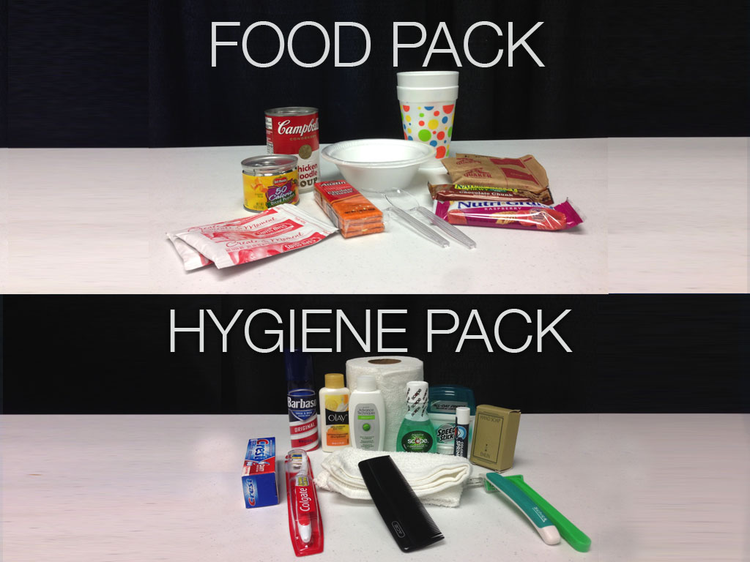

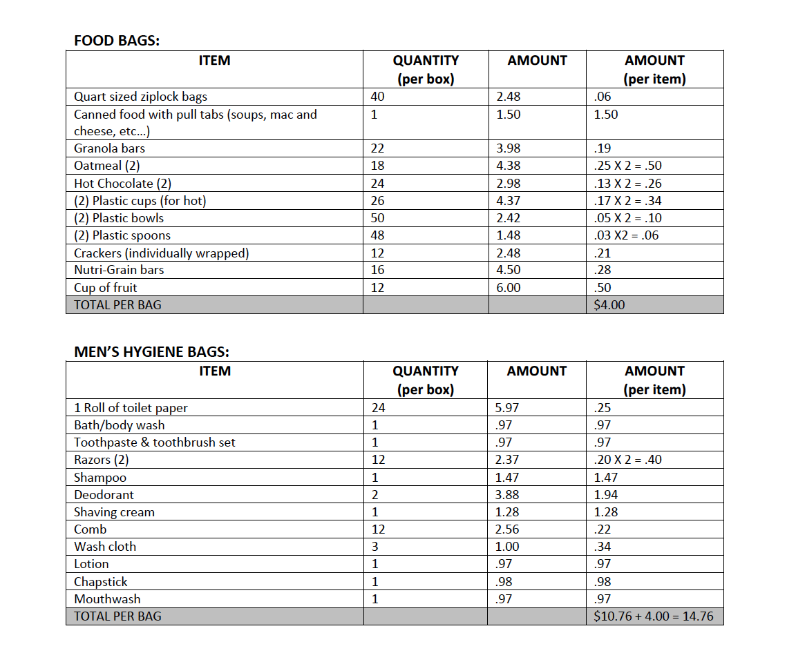

_____________________________________________ ___________________________________________
Lance Moore Gene Roncone
Lead Pastor
Boy Scout Troop 52 Highpoint Church

